Business Question and Visualization Report
Team ID | MCA
Project Name | Smartphone Usage, Digital Addiction & Well-Being Analysis
Maximum Marks | 5 Marks

Visualization Development
Visualization development refers to the process of creating graphical representations of data to facilitate understanding, analysis, and decision-making. The goal is to transform complex datasets into visual formats that are easy to interpret, enabling users to gain insights and make informed decisions. This report presents the Power BI visualizations developed for the Smartphone Usage, Digital Addiction & Well-Being Analysis project.

Business Questions and Visualization
The following business questions are mapped directly to the visuals and interactive filters visible in the submitted Power BI dashboard. Each screenshot is placed in the right-side column so that the question, visualization description and actual dashboard visual can be viewed together.

Business Questions and Visual Mapping Table
No. | Business Question | Visualization Type & Description | Artifact Requirement
1 | How does the average daily screen time differ across genders? | Column Chart – Average Daily Screen Time by Gender  Compares average daily screen time for Male, Other and Female categories shown in the dashboard. | 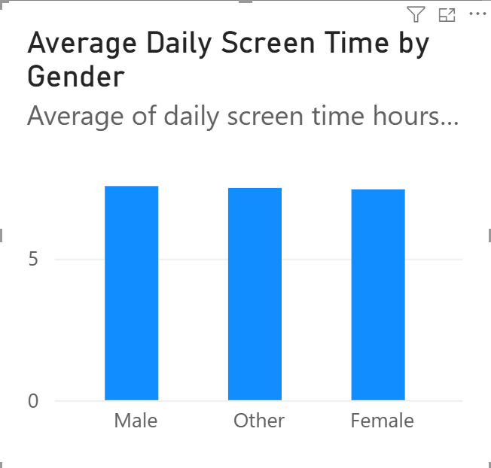
2 | What is the distribution of users across different levels of device addiction? | Horizontal Bar Chart – Users by Addiction Level  Shows the number of users across the Mild, Moderate, None and Severe addiction-level categories displayed in the dashboard. | 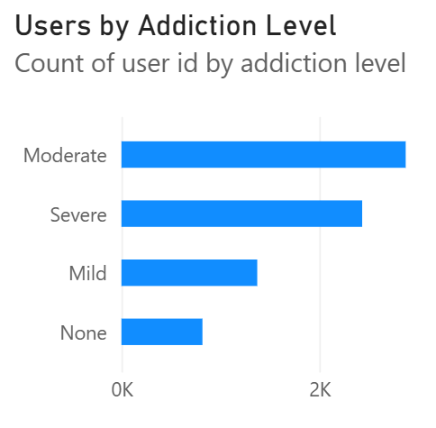
3 | What proportion of users is classified as addicted versus non-addicted? | Donut Chart – Addicted vs Non-Addicted Users  Displays the addicted and non-addicted portions of the total user population; the dashboard center shows 7.5K. | 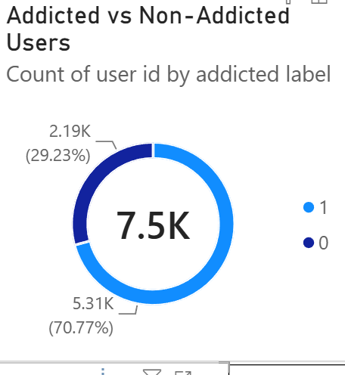
4 | Which age group shows differences in average daily screen time? | Column Chart – Average Daily Screen Time by Age Group  Compares average daily screen time for the age groups shown in the dashboard: 30–39, 20–29 and Under 20. | 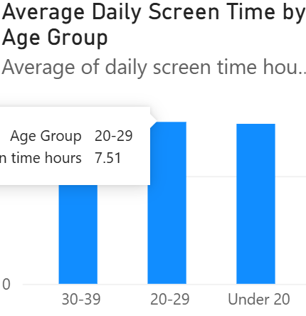
5 | Is there a visible relationship between daily screen time and sleep hours? | Scatter Plot – Daily Screen Time vs Sleep Hours  Plots daily screen time against sleep hours to visually examine the distribution of users. | 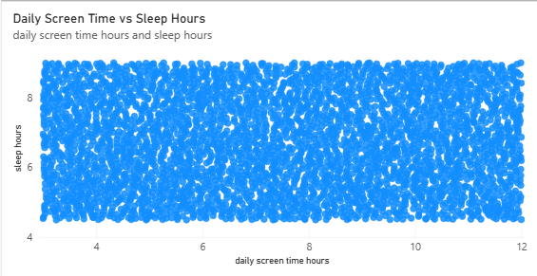
6 | How does average gaming time compare with average social-media usage? | Clustered Column Chart – Average Gaming vs Social Media Usage  Places average gaming hours and average social-media usage side by side for comparison. | 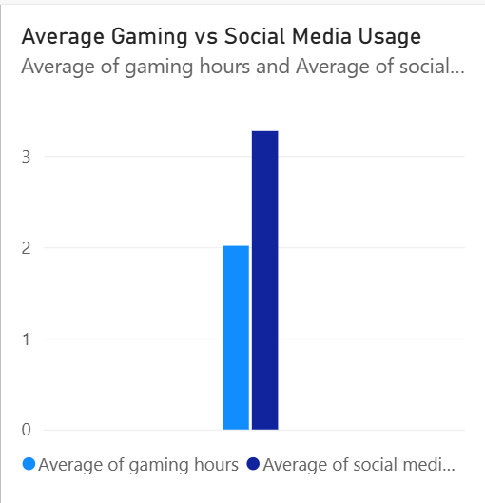
7 | How can gender and addiction-level filters be used to view the dashboard dynamically? | Slicers – Gender and Addiction Level  Shows the interactive filters available for Female, Male, Other and the addiction-level categories. | 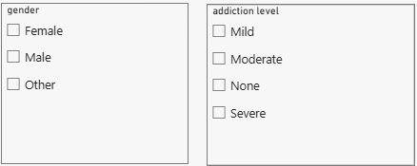
8 | How can the dashboard be filtered by age group? | Slicer – Age Group  Shows the age-group filter available for 20–29, 30–39 and Under 20. | 